[ Insert official UPAEP logo ]
UPAEP · Decanato de Ingenierías
EVIDENCE — US10-T2
Design the threshold configuration screen
SmartGreenAI: Cilantro Crop

1. Task information
Task ID | US10-T2
User Story | US-10 — Configure sensor thresholds
Sprint | Sprint 2 (2026-09-21 – 2026-10-09)
Week | Week 1
Responsible | Jorge Velez Delgado
Peer reviewer | Alexis Enrique Valle Parra
Planned / actual hours | 3 h / 3 h
Completed on | September 25, 2026
Status | Done

2. Task description
Create a prototype of the screen: one row per variable with its current min/max, unit, edit button and save/cancel actions.

3. Completion conditions
✓ Condition 1: Prototype shows one row per variable with min, max and unit.
How it was verified: The screen (realised prototype) shows one row per variable of the area with its current minimum, maximum and unit.
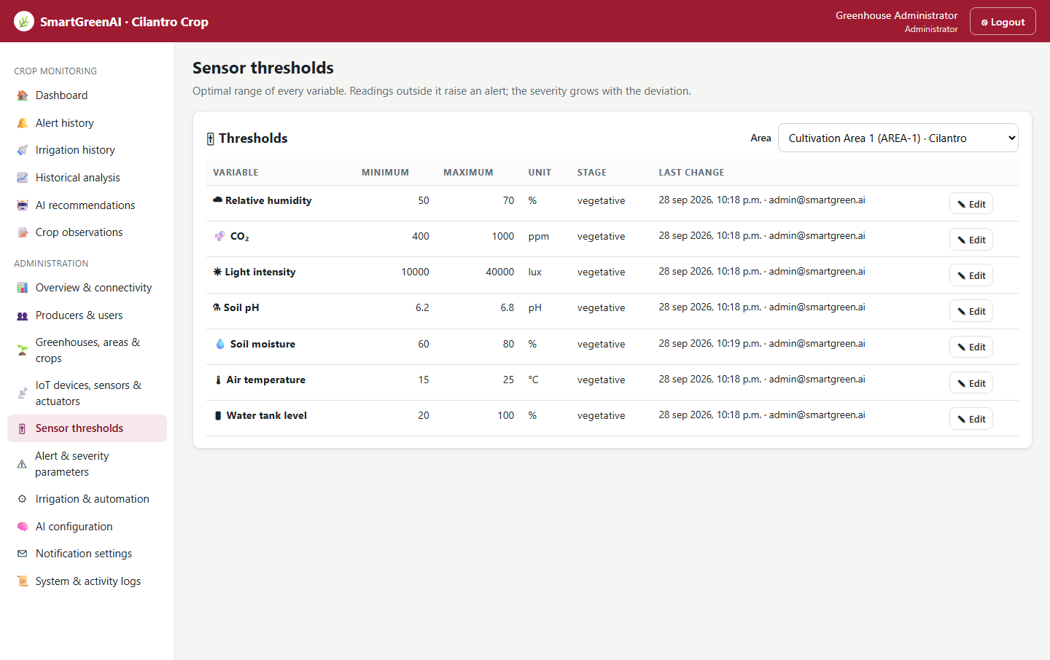
Figure US10-T2-1. Threshold configuration screen: one row per variable with its minimum, maximum, unit, crop stage, last change and an Edit button. (US10-T2_Design_Threshold_Configuration_Screen_1.png)
✓ Condition 2: Edit, save and cancel actions are included.
How it was verified: Each row has an Edit button; in edit mode it offers Save and Cancel. Cancel restores the stored values without saving.
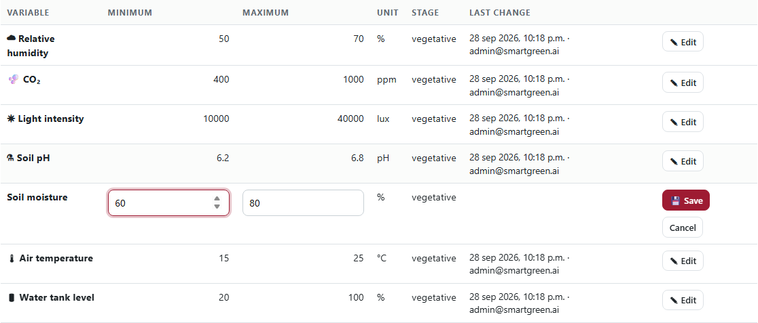
Figure US10-T2-2. Editing a row: the minimum and maximum become inputs and the Save and Cancel actions appear. (US10-T2_Design_Threshold_Configuration_Screen_2.png)
public/js/pages/thresholds.js — lines 32–71
function renderRow(t) {
const tr = h('tr', { 'data-type': t.sensor_type });
const view = () => clear(tr,
h('td', {}, h('strong', {}, `${SENSOR_ICONS[t.sensor_type] || ''} ${SENSOR_LABELS[t.sensor_type] || t.sensor_type}`)),
h('td', { class: 'num' }, String(t.min_value)),
h('td', { class: 'num' }, String(t.max_value)),
h('td', {}, unitLabel(t.unit)),
h('td', {}, t.crop_stage || '—'),
h('td', { class: 'small' }, `${fmtDate(t.updated_at)}${t.updated_by_email ? ` · ${t.updated_by_email}` : ''}`),
h('td', {}, h('button', { class: 'sm', onclick: edit }, '✎ Edit')));
const edit = () => {
const min = h('input', { type: 'number', step: 'any', 'aria-label': 'Minimum', value: t.min_value });
const max = h('input', { type: 'number', step: 'any', 'aria-label': 'Maximum', value: t.max_value });
min.value = t.min_value;
max.value = t.max_value;
const err = h('div', { class: 'error', role: 'alert' });
const save = async () => {
err.textContent = '';
if (min.value === '' || max.value === '') { err.textContent = 'Both values are required.'; return; }
if (Number(min.value) >= Number(max.value)) { err.textContent = 'The minimum must be lower than the maximum.'; return; }
try {
Object.assign(t, await put(`/thresholds/${t.id}`, { min_value: Number(min.value), max_value: Number(max.value) }));
toast(`${SENSOR_LABELS[t.sensor_type]} threshold saved.`);
view();
} catch (e) {
err.textContent = [e.message, ...(e.details || []).map((d) => d.issue)].filter(Boolean).join(' ');
}
};
clear(tr,
h('td', {}, h('strong', {}, SENSOR_LABELS[t.sensor_type] || t.sensor_type), err),
h('td', {}, min), h('td', {}, max), h('td', {}, unitLabel(t.unit)), h('td', {}, t.crop_stage || '—'), h('td'),
… (8 more lines)

✓ Condition 3: Prototype reviewed by the team.
How it was verified: The prototype was reviewed by the team in the Week 1 milestone review (approval record below).
✓ Condition 4: Evidence: Screen prototype (Figma or similar) reviewed by the team.
How it was verified: Screen prototype reviewed by the team (Figures 1–2 show the implemented design).

4. Attached files
- US10-T2_Design_Threshold_Configuration_Screen_1.png
- US10-T2_Design_Threshold_Configuration_Screen_2.png

5. Traceability
Related requirements | FR-12, NFR-06
Implementation | See docs/TRACEABILITY.md
Verification | See docs/TRACEABILITY.md

6. Sign-off
Role | Name | Date | Signature
Responsible | Jorge Velez Delgado | September 25, 2026
Peer reviewer | Alexis Enrique Valle Parra | September 25, 2026
Product Owner acceptance | Alexis Enrique Valle Parra | September 25, 2026
Approval record: Daily Meeting 2 of Sprint 2 (Monday, September 28, 2026), team update: Jorge Velez Delgado — "US10-T1 and US10-T2 finished".

